**Experiment 10: (Triggers)**

**Aim:**

* Create a table with attribute sname, and another table with newname.
* Create a trigger to insert into second table before inserting in first table.
* Create a table for account details with attributes account number and an amount.
* Create a trigger to check if amount is negative or greater than zero before inserting to table.

**SOLUTION:**

**Components:**

Triggers: A trigger is a special type of stored procedure that automatically runs when an event occurs in the database server.

CODE:

create table test(sname varchar(20));

create table test_audit(newname varchar(20));

CREATE TRIGGER before_test_update

BEFORE INSERT ON TEST

FOR EACH ROW

INSERT INTO test_audit

SET newname = NEW.sname;

insert into test values ('sahithi');

select * from test;

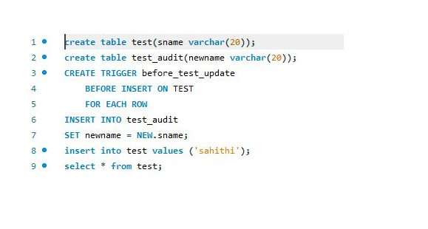

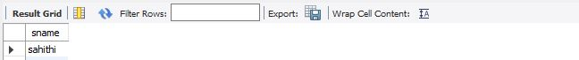



select * from test_audit;

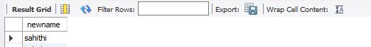

CREATE TABLE accB (acct_num INT ,amount DECIMAL(10,2));

delimiter //

CREATE TRIGGER che1 BEFORE insert ON accB

FOR EACH ROW

BEGIN

IF NEW.amount < 0 THEN

SET NEW.amount = 0;

ELSEIF NEW.amount > 100 THEN

SET NEW.amount = 100;

END IF;

END;//

delimiter ;

insert INTO accB VALUES(100,-14.98);

select * from accB;

INSERT INTO accB VALUES(200,500);

INSERT INTO accB VALUES(300,-14.98);

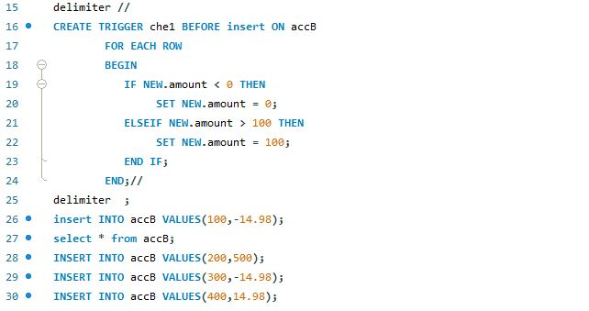

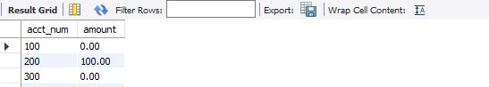

INSERT INTO accB VALUES(400,14.98);

